Lab Objective

Learn how to Configure Processing and Precedence of GPOs

**Lab Procedures**

**1.** Log in to RWDC01 as the **Contoso\administrator** user account with the password of **Password01**. The Server Manager console opens.

**2.** Using Server Manager, click Tools > Active Directory Users and Computers. The Active Directory Users and Computers console opens.

**3.** Under the Sales OU, create an East OU and a West OU.

**4.** Using Server Manager, click Tools > Group Policy Management. The Group Policy Management console opens.

**5.** Navigate to and click the Sales OU.

**6.** Right-click the Sales OU and click *Create a GPO in this domain, and Link it here*. When the New GPO dialog box opens, type in **GPO1**. Click OK.

**7.** Create a GPO called **GPO2** for West OU.

**8.** Create a GPO called **GPO3** for the East OU.

**9.** Create a GPO called **GPO4** for the contoso.com domain.

**10.** Create a GPO called **GPO5** for the Sales OU.

**11.** Create a GPO called **GPO6** for the East OU.

**12.** Create a GPO called **GPO7** for the East OU.

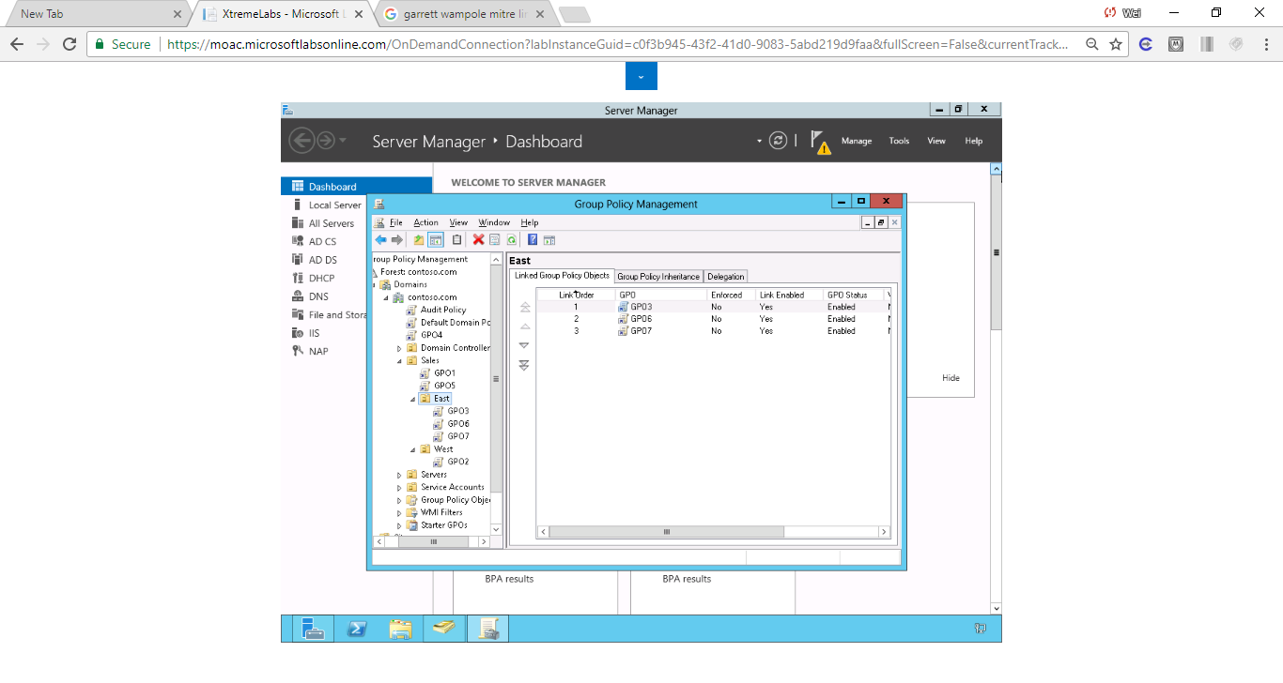

Figure Screenshot shows GP objects created in ascending order.

**13.** ClickEast OU, as shown in Figure 19-1. In the East pane, click Group Policy Inheritance.

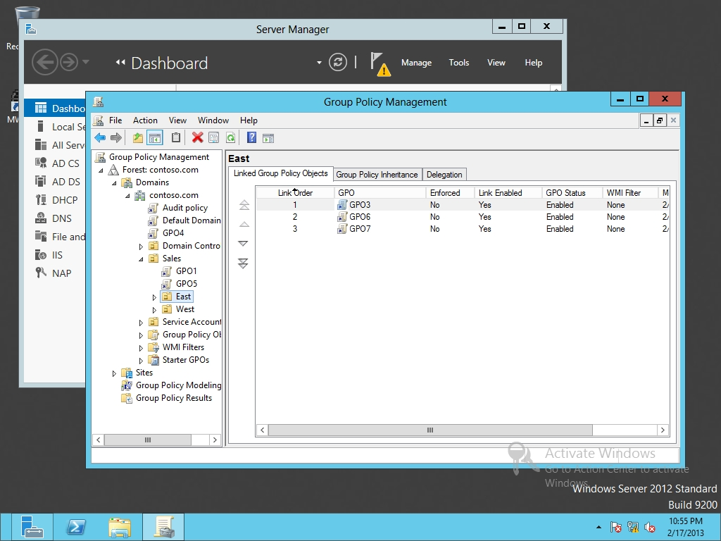

Figure 19-1

Viewing GPOs linked to a OU

**14.** For the East OU, click Linked Group Policy Objects.

**15.** Click GPO7. Then click the double up arrow.

**16.** Click the Group Policy Inheritance tab.

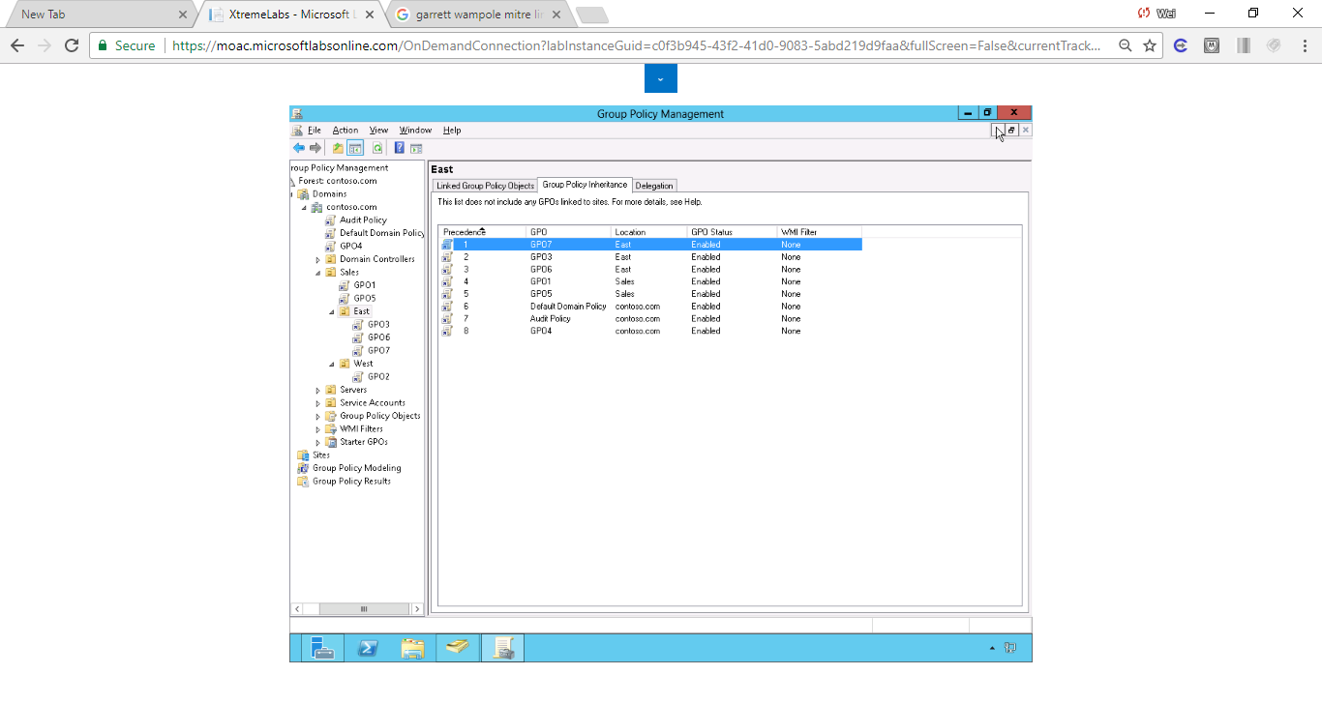

Figure Order of the GPO listed in Group Policy Inheritance tab

**17.** Take a screen shot of the Group Policy Management window by pressing Alt+Prt Scr and then paste it into your Lab19_worksheet file in the page provided by pressing Ctrl+V.

**18.** Keep the Group Policy Management console open for the next exercise.

End of exercise.

**Lab Summary**

[In this exercise, I created multiple GPOs and looked at overall precedence of the GPOs. The precedence of the GPOs assigned to the OU usually takes by the names in ascending order. The GPO assigned to the OU usually takes the precedence over those assigned to its parent](https://www.google.com/search?rlz=1C1CHBF_enUS720US720&q=I+this+exercise,+I+created+multiple+GPOs+and+looked+at+overall+precedence+of+the+GPOs.+The+precedence+of+the+GPOs+assigned+to+the+OU+usually+takes+by+the+names+in+ascending+order.+The+GPO+assigned+to+the+OU+usually+takes+the+precedence+over+those+assigned+to+its+parents.&spell=1&sa=X&ved=0ahUKEwjL3_TIkurXAhVF7GMKHf3qC68QBQgmKAA). The order can be adjusted by double up arrows.